Iteration 3 Report

Public Health App, Team Coding Touchdown

1. **Customer Meeting Date to Demo**

Nov 4, Friday, 3:00pm, via Zoom

1. **User Story Implemented**

The user story “Saving and Checking Screening Results” was implemented.

This user story implemented the function of letting the users to store and check the survey result so that they could access the result later and also check determinants affecting their health.

1. **Design Diagram**

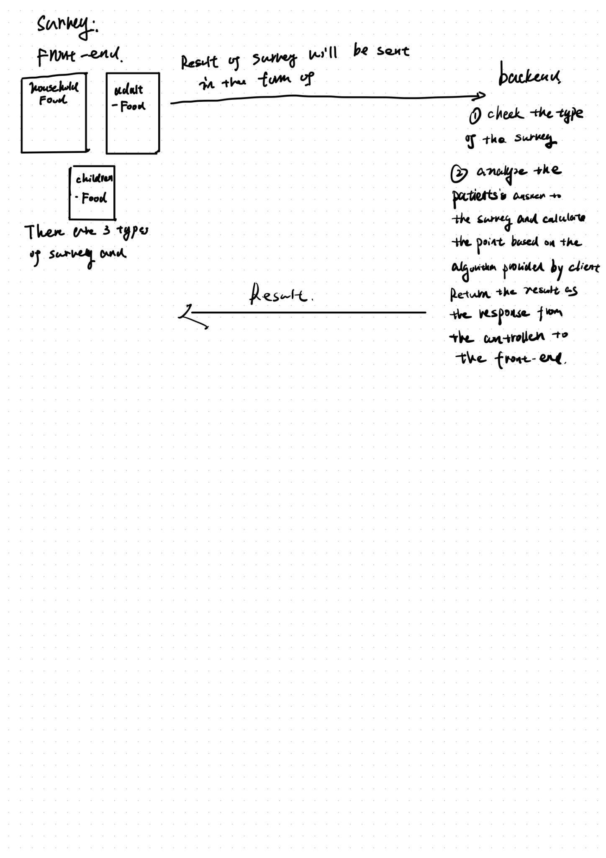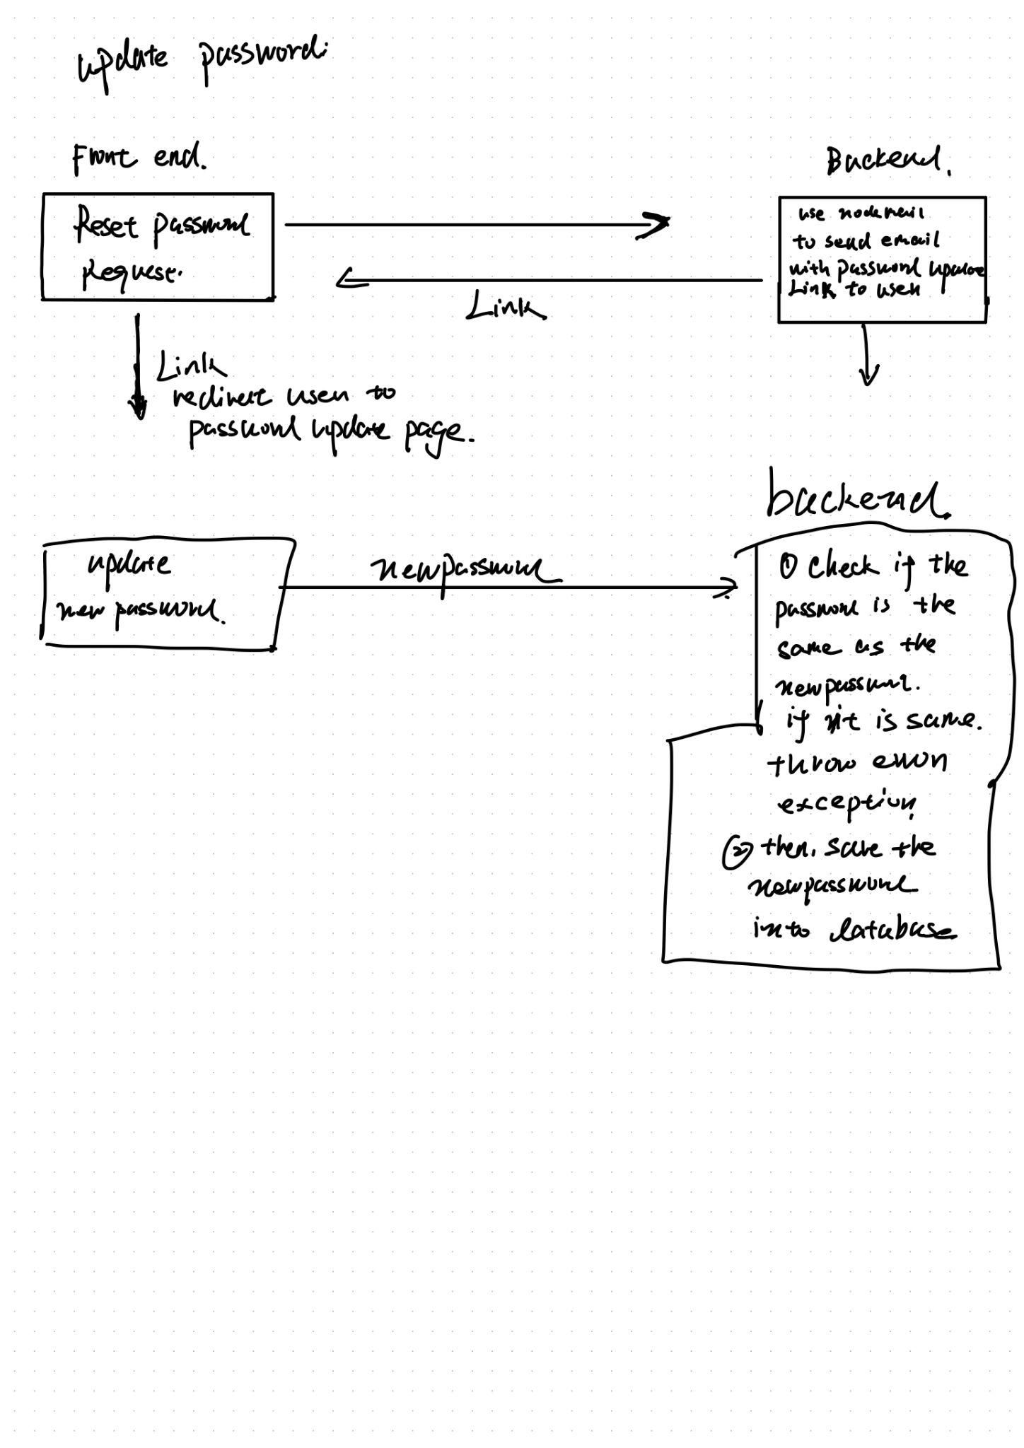

1. **Note to the User Story**

We add another feature to this user story, which is the password reset.

1. **Evaluation of the Code and Tests**

You could run the test case by ‘npm test’ in the public-health-app folder.

The coverage of the code will also be displayed. Before running the code please run the ‘npm install -f “ and “npm install -f nodemail” to install the essential dependencies for the project in order to run the test.

1. **Links**

Pivotal Tracker: <https://www.pivotaltracker.com/n/projects/2596722>

GitHub repo: <https://github.com/Patrickyyh/public-health-app>

Heroku deployment: <https://publichealthapp.herokuapp.com/register>